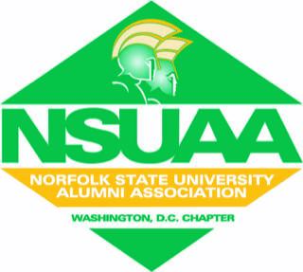
NORFOLK STATE UNIVERSITY ALUMNI ASSOCIATION
MEMBERSHIP APPLICATION Membership Year is July 1 - June 30
Name __________________________________________________________________
Address ________________________________________________________________
City _________________________ State _______________ Zip___________________
Telephone No. Home ( ) ___________________ Work ( ) _____________________
E-mail _________________________________________________________________
Date of Birth ______________

Types of Membership (check one box):
□ General $75 Alumnus/Former student ($50 Local Dues & $25 National Dues)
□ Associate $75 Non-Alumnus/Friend of NSU ($50 Local Dues & $25 National Dues)
□ Life* $750

* Life Membership Payment Plan (if you are opting to make payments):
□ Full payment $750 (enclosed)
□ Two-year Plan $375 Year One (enclosed), $375 Year Two**
□ Three-year Plan $250 Year One (enclosed), $250 Year Two, $250 Year Three**
Please Note: To be considered a financial member of the NSUAA, while on the life membership payment plan, you must submit the annual membership dues of $50.

Have you ever been a Chapter member? □ Yes □ No
Chapter Name ___________________________________________________________
Did you attend NSU? □ Yes □ No If yes, what year did you graduate? _______________
What year(s) did you attend?________________________________________________
Major__________________________________________________________________
Degree or certificate earned ________________________________________________

If you have not submitted your payment online, please mail completed application along with check or money order to:
NSUAA-Washington, DC
P.O. Box 77781
Washington, DC 20013

Based on your Membership type selected above, submit the associated payment using one of the two QR codes below (PayPal or Venmo). Do not forget to add your name to the notes/comment section before sending payment and what fiscal year the payments are to be paid against. Once completed, please send your membership application to the chapter email nsuaadcchapter@gmail.com.

